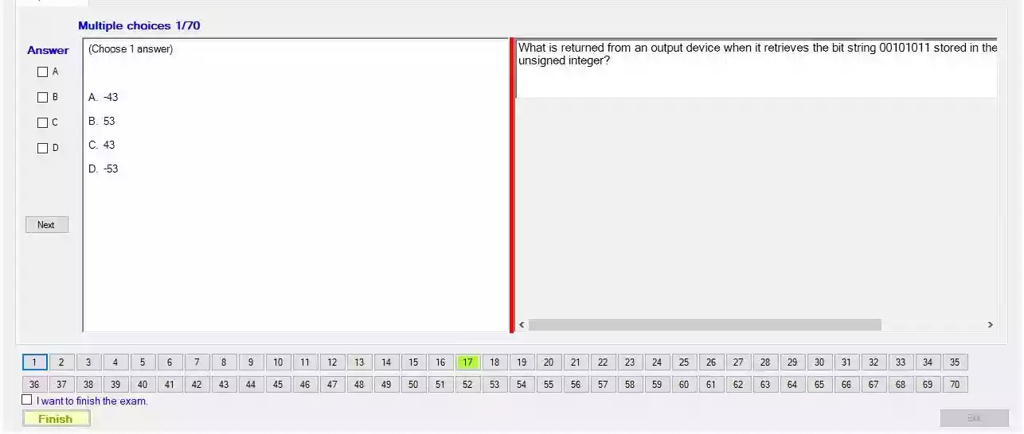

What is returned from an output device when it retrieves the bit string 00101011 stored in the unsigned integer?

1. - 43

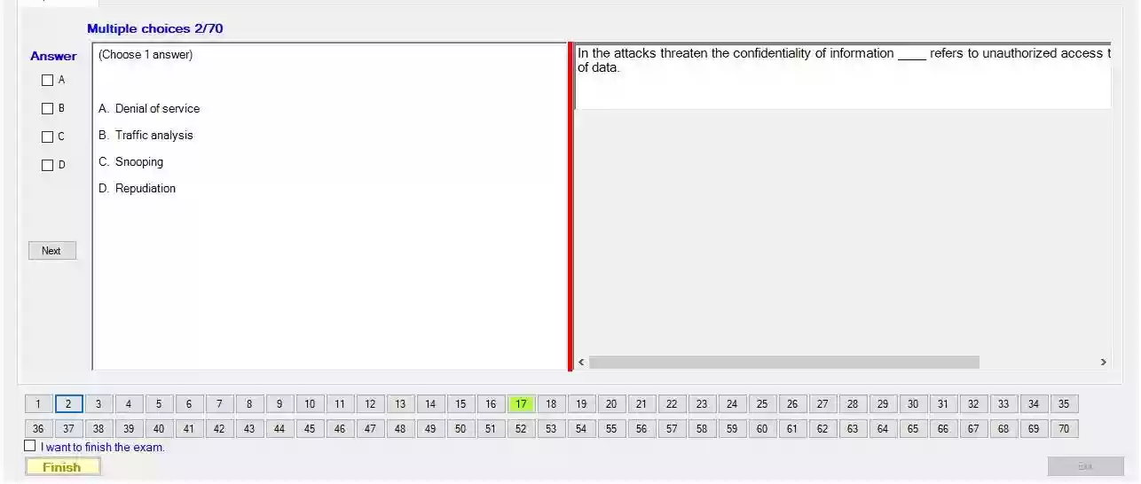

In the attacks threaten the confidentiality of information ____ refers to unauthorized access of data.

C/ Snooping

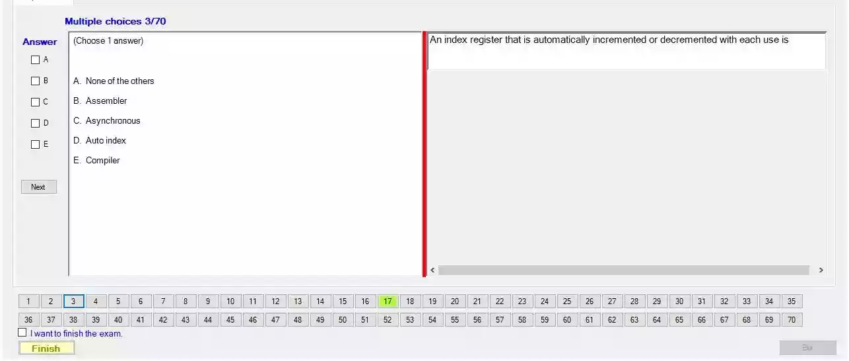

An index register that is automatically incremented or decremented with each use is

D. Auto index

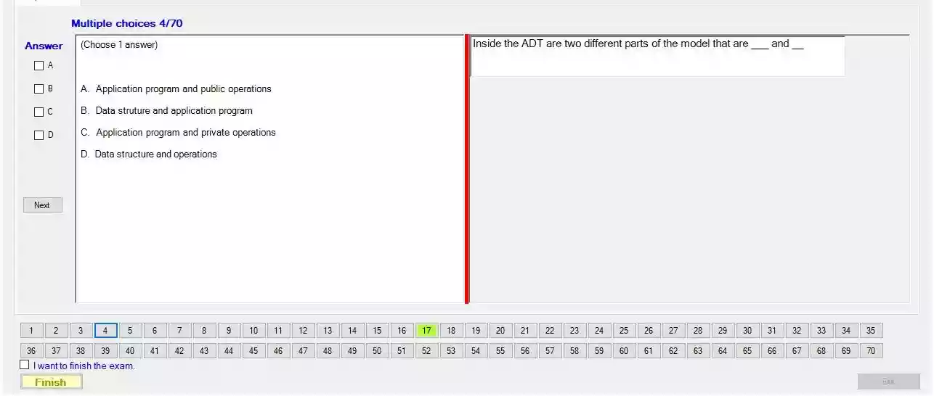

Inside the ADT are two different parts of the model that are ___ and ___

B/ Data struture and application program

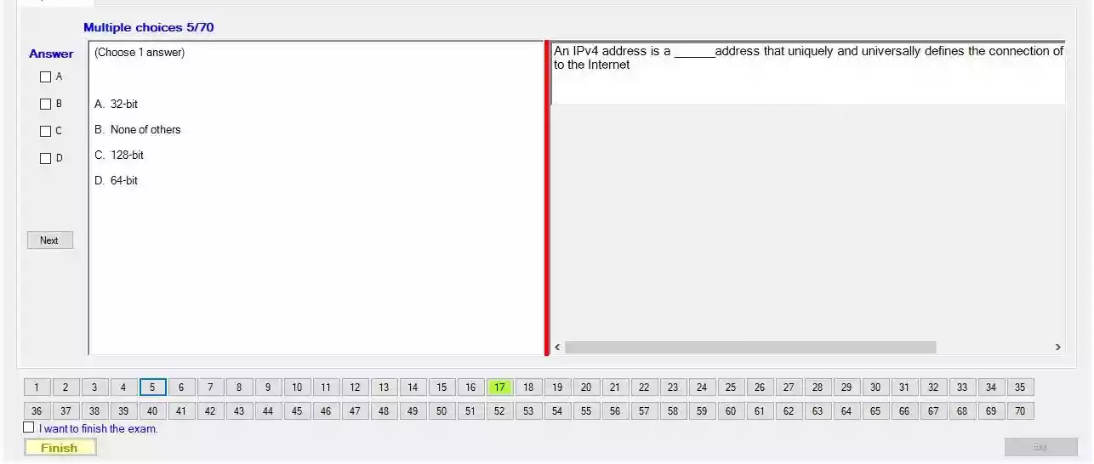

An IPv4 address is a ____ address that uniquely and universally defines the connection of to the Internet

- A.32bit

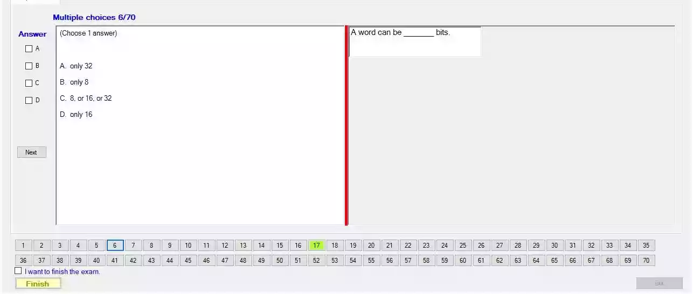

A word can be ___ bits.

C. 8, or 16, or 32

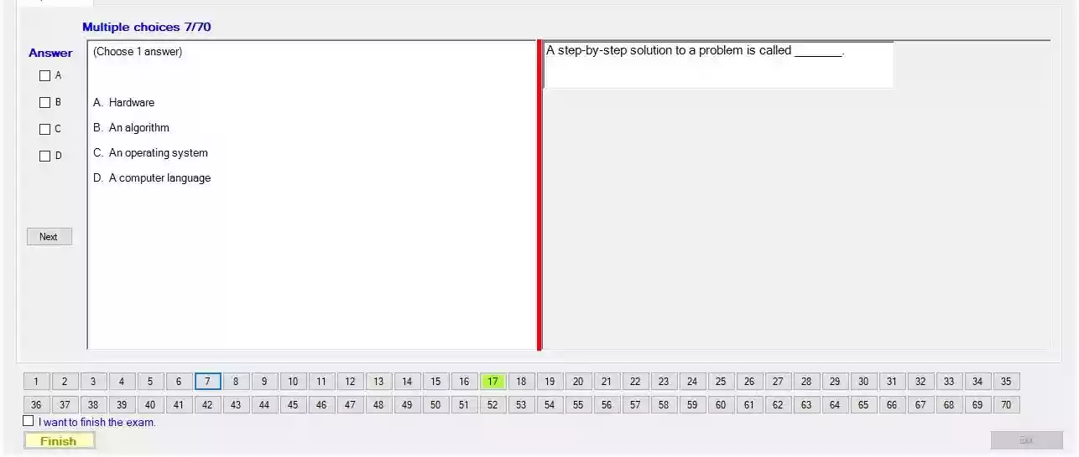

A step-by-step solution to a problem is called

B/ An algorithm ( thuật toán )

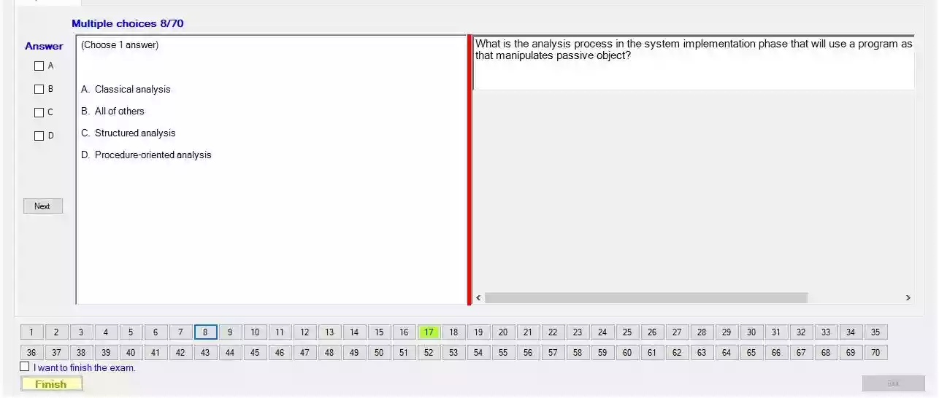

What is the analysis process in the system implementation phase that will use a program as that manipulates passive object?

C/ Structured analysis

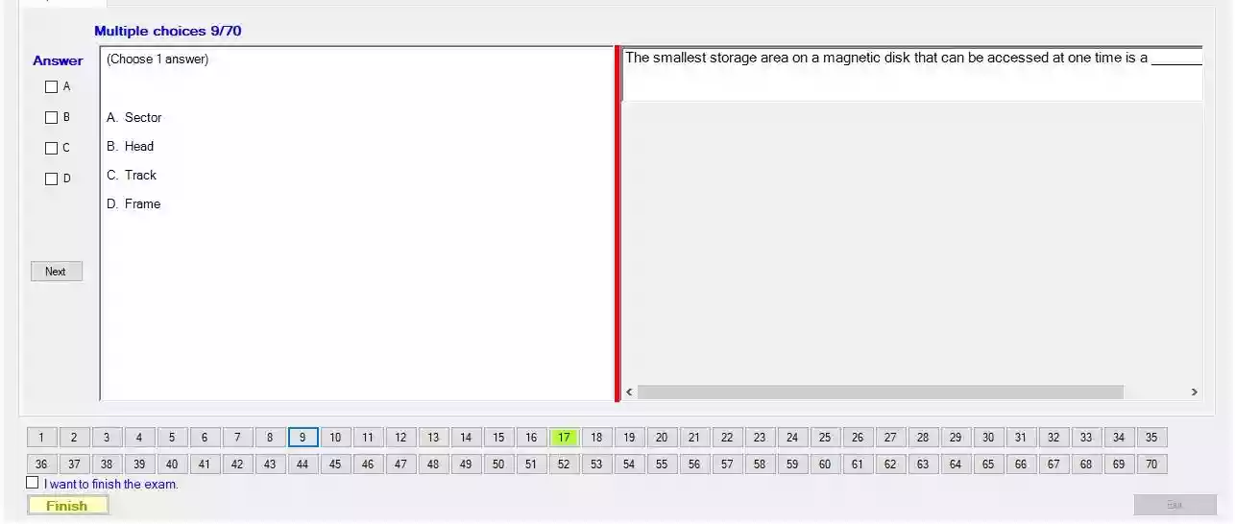

The smallest storage area on a magnetic disk that can be accessed at one time is a

A/ Sector

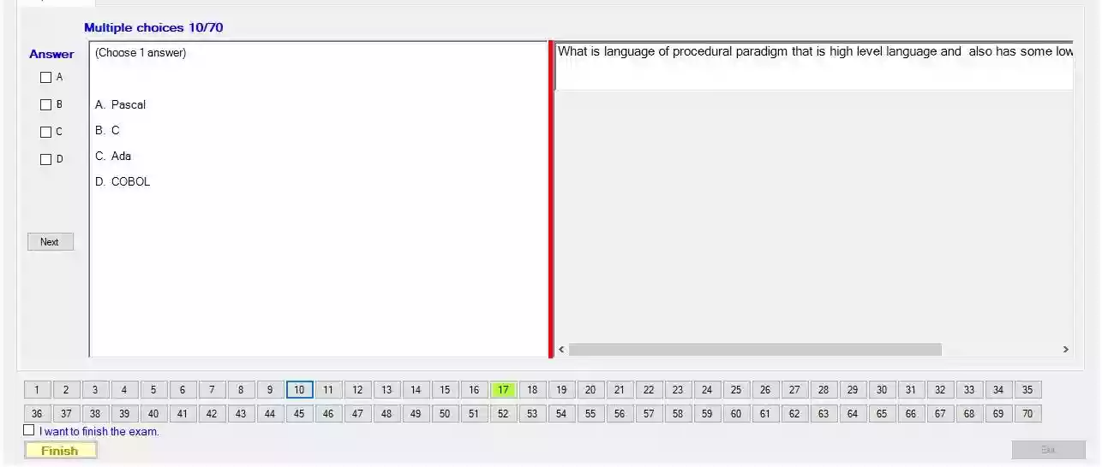

What is language of procedural paradigm that is high level language and also has some low

B. C

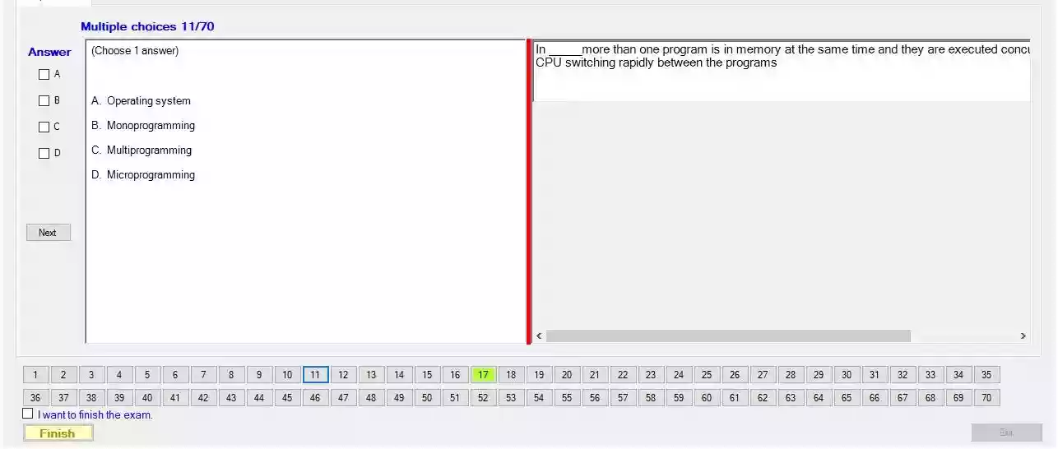

In ___ more than one program is in memory at the same time and they are executed conci CPU switching rapidly between the programs

C/ Multiprogramming

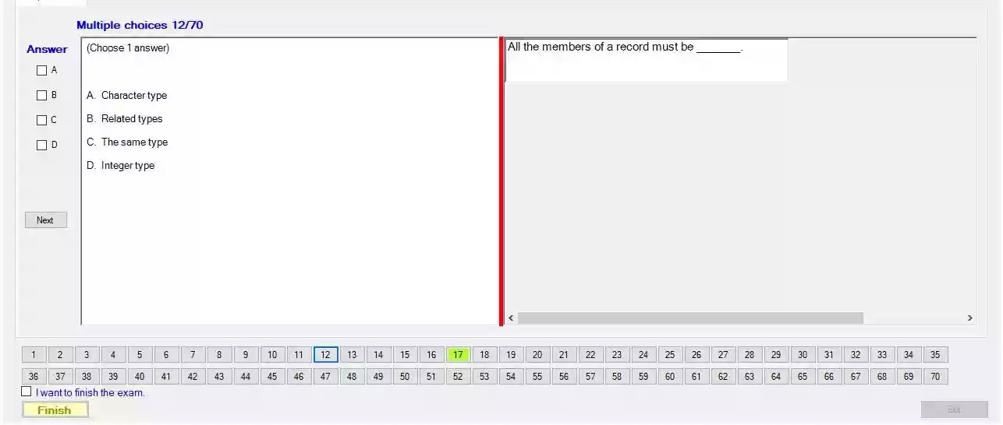

All the members of a record must be

C/ The same type

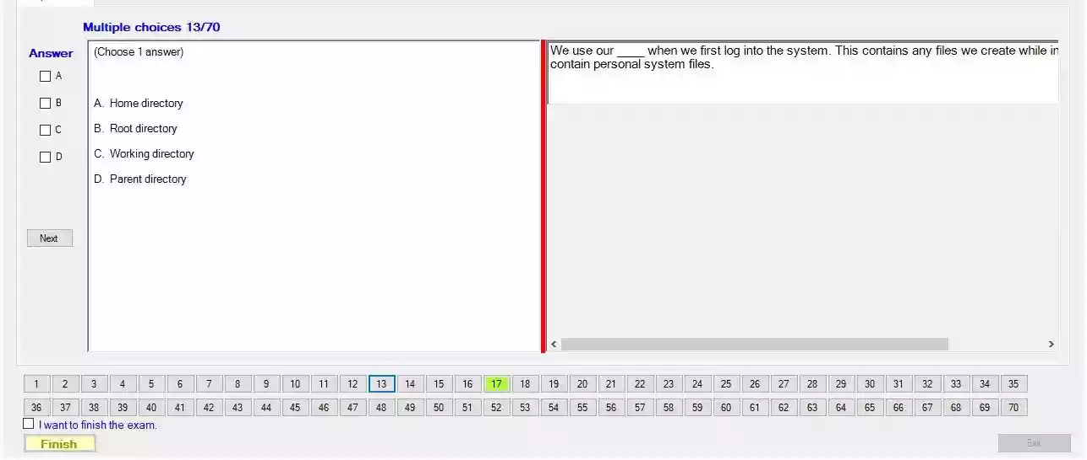

when we first log into the system. This contains any files we create while in contain personal system files.

A/ Home directory

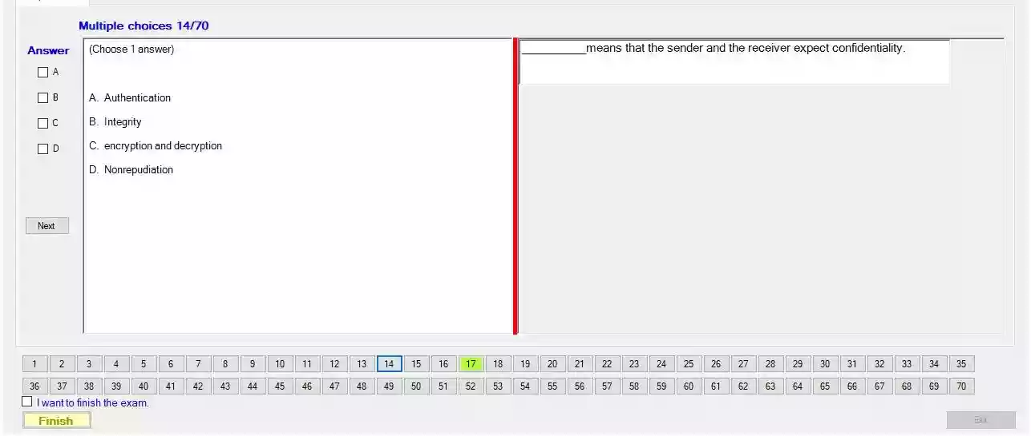

___ means that the sender and the receiver expect confidentiality.

C/ encryption and decryption

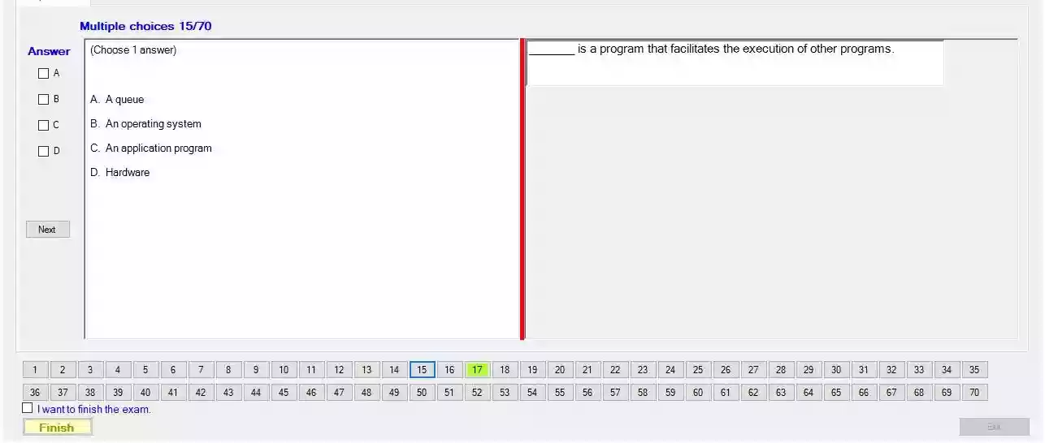

is a program that facilitates the execution of other programs.

C/ An operating system

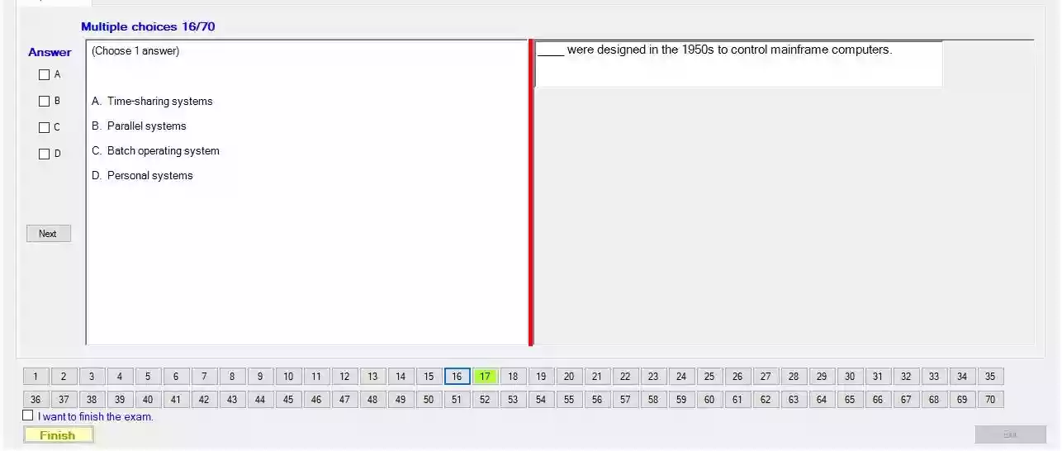

___ were designed in the 1950s to control mainframe computers

C/ Batch operating system

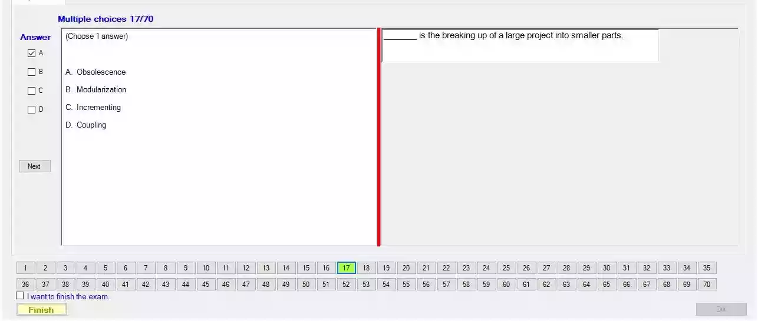

___ is the breaking up of a large project into smaller parts

B/ Modularization.

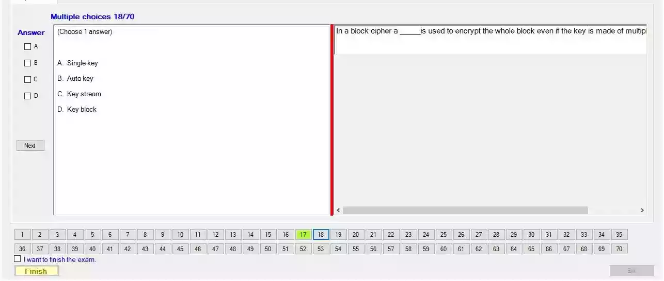

In a block cipher a ___ is used to encrypt the whole block even if the key is made of multipl

A/ Single key.

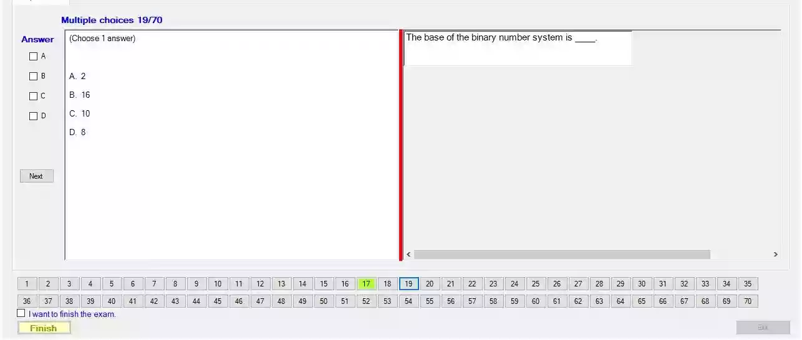

The base of the binary number system is __

A/ 2

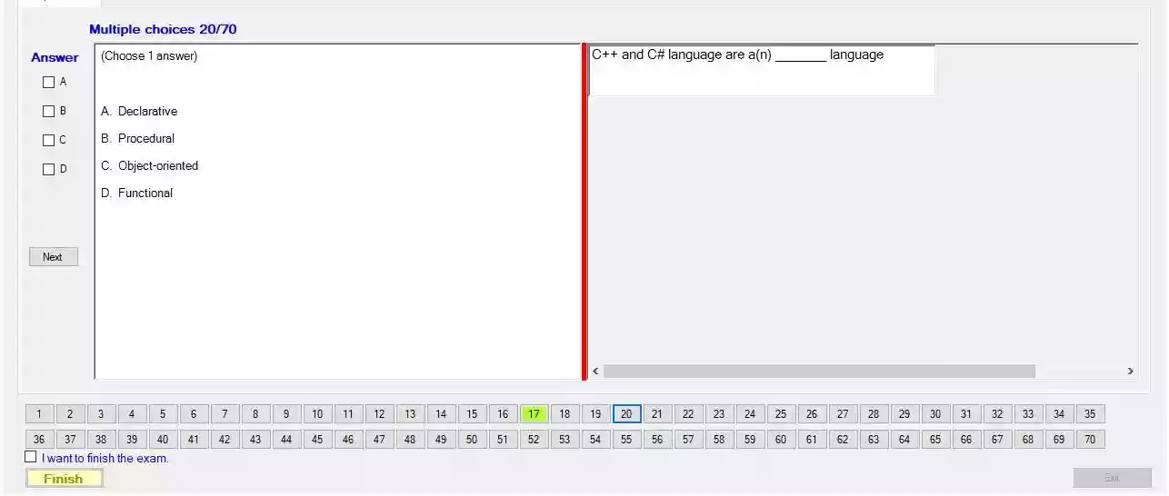

C++ and C# language are a(n) __ language

C/ Object-oriented.

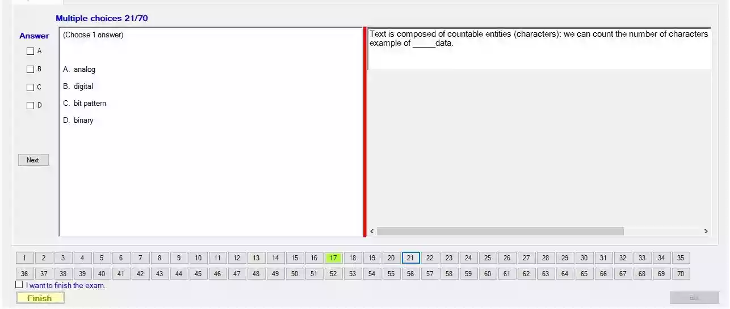

Text is composed of countable entities (characters): we can count the number of characters example of ___ data.

B/ Digital

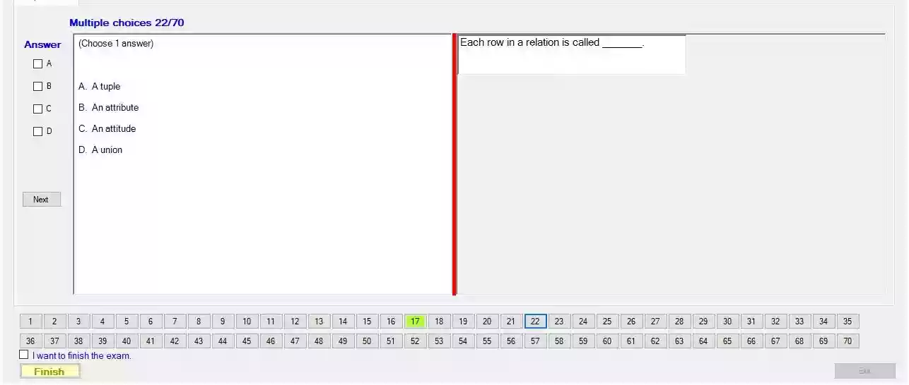

Each row in a relation is called

A. A tuple

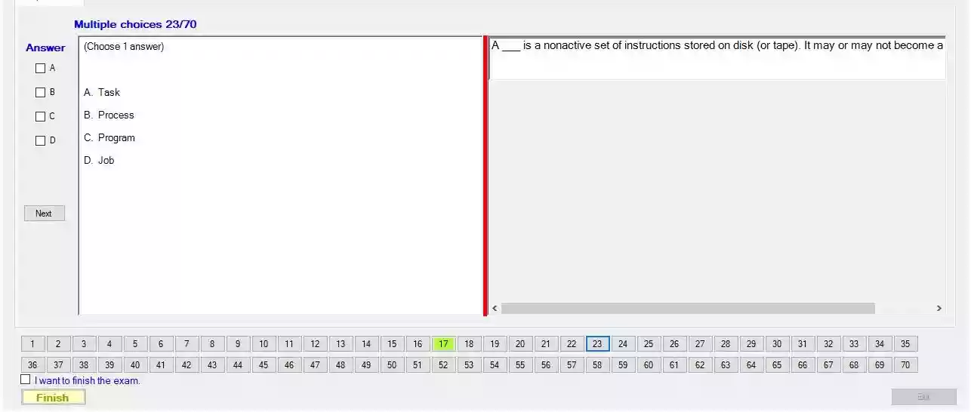

A ___ is a nonactive set of instructions stored on disk (or tape). It may or may not become a

C. Program

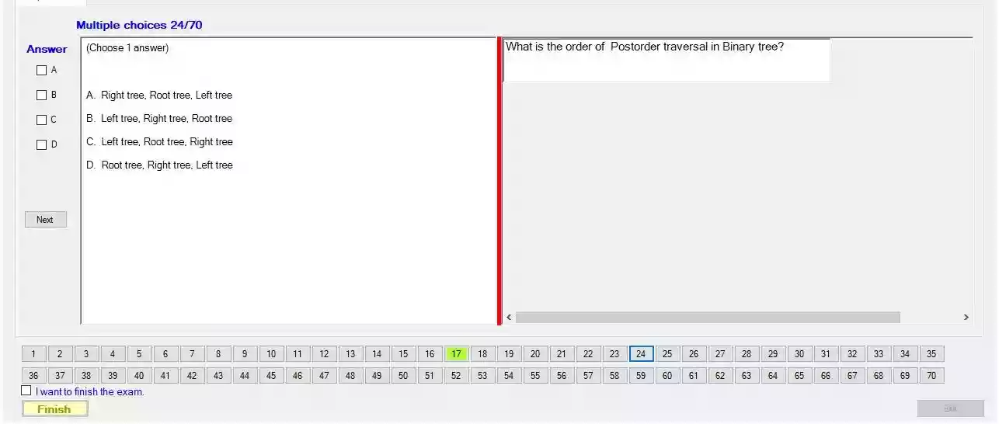

What is the order of Postorder traversal in Binary tree?

D. Root tree, Right tree. Left tree

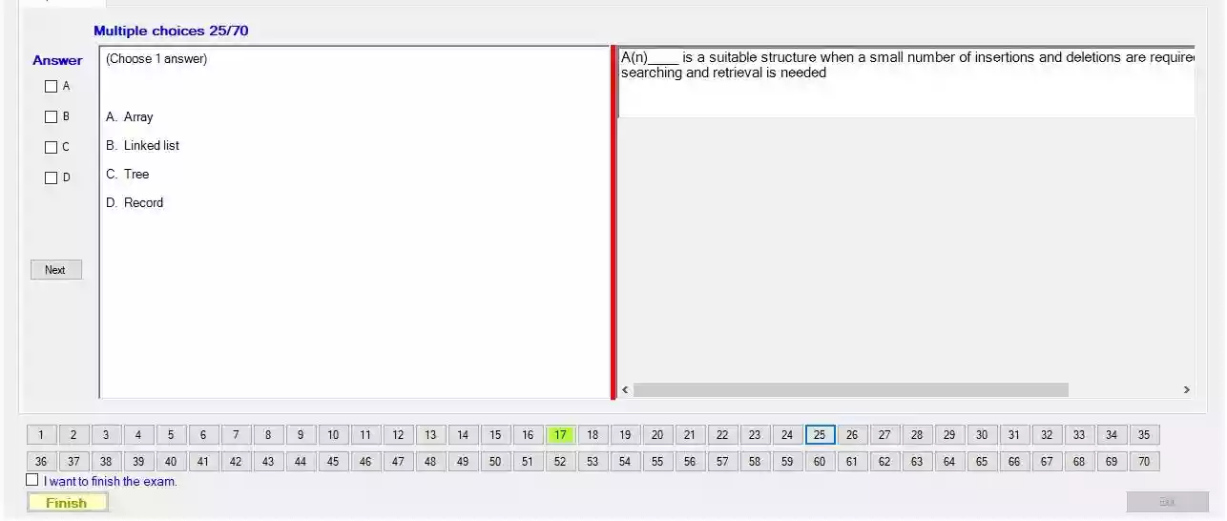

A(n) ___ is a suitable structure when a small number of insertions and deletions are require

searching and retrieval is needed

B/ Linked list

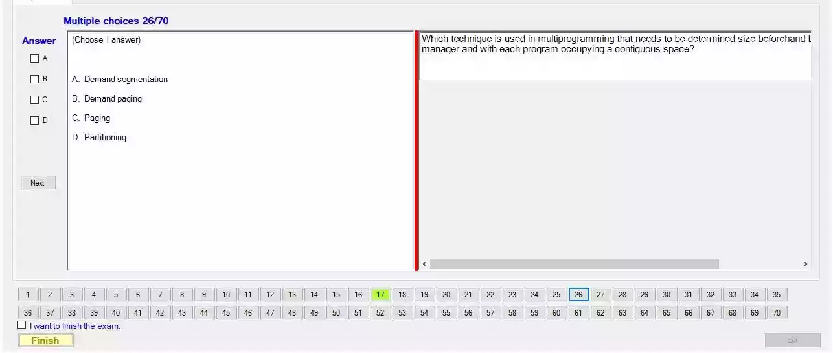

Which technique is used in multiprogramming that needs to be determined size beforehand t manager and with each program occupying a contiguous space?

D. Partitioning.

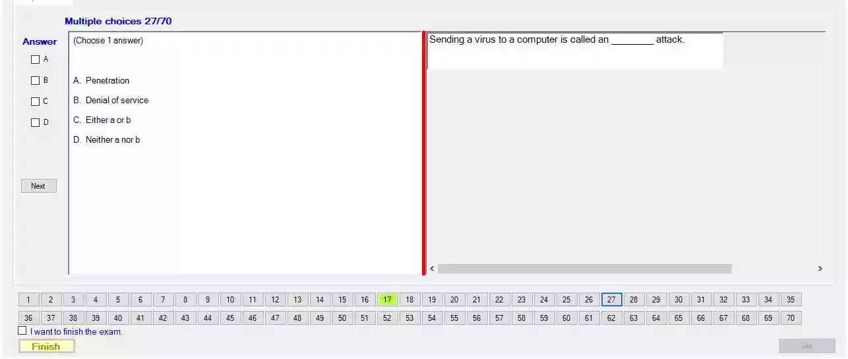

Sending a virus to a computer is called an __ attack.

A/ Penetration.

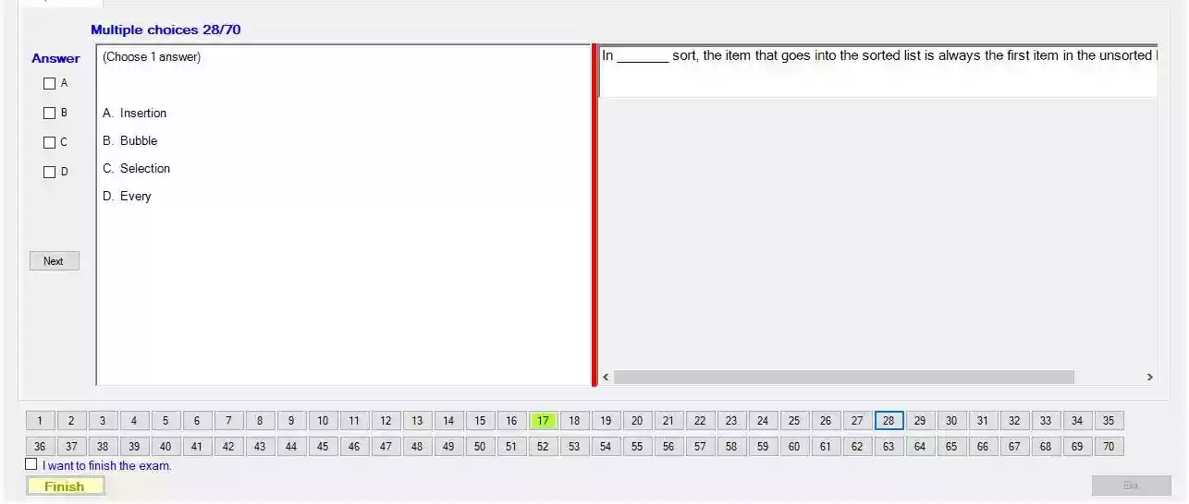

In __ sort, the item that goes into the sorted list is always the first item in the unsorted

A/ Insertion

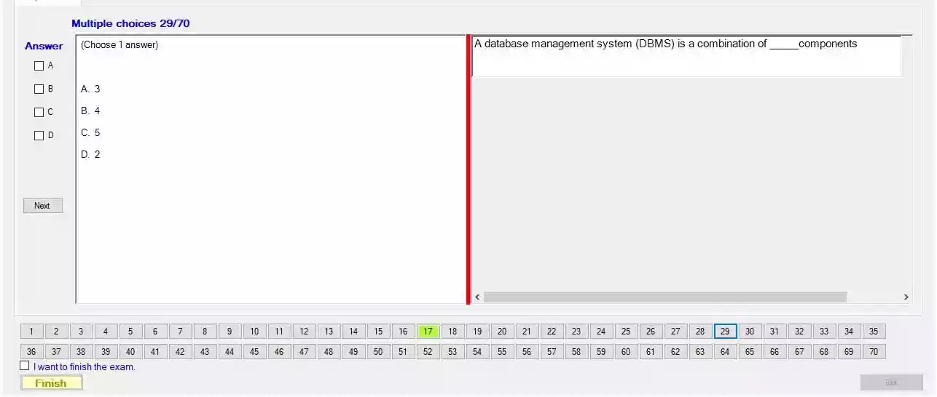

A database management system (DBMS) is a combination of ___ components

A/ 3

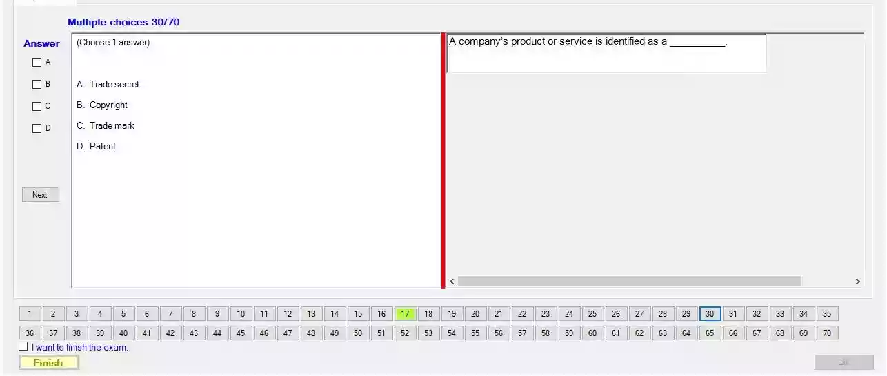

A company's product or service is identified as a

C. Trade mark

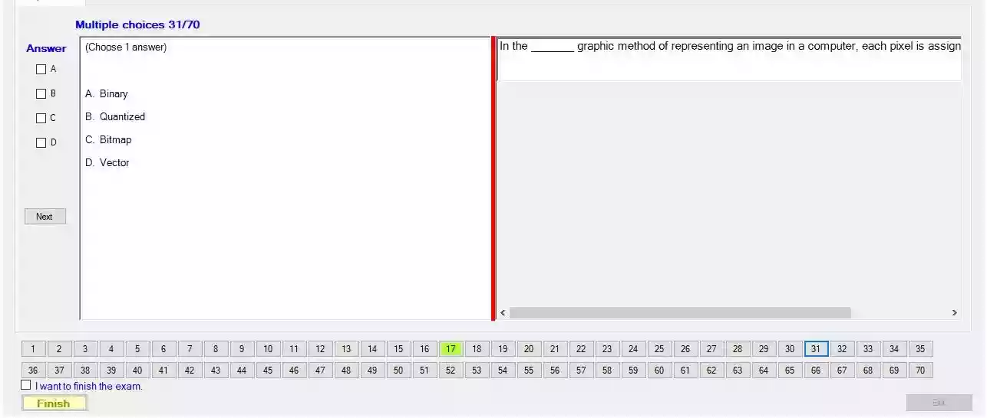

In the ___ graphic method of representing an image in a computer, each pixel is assign

C/ Bitmap

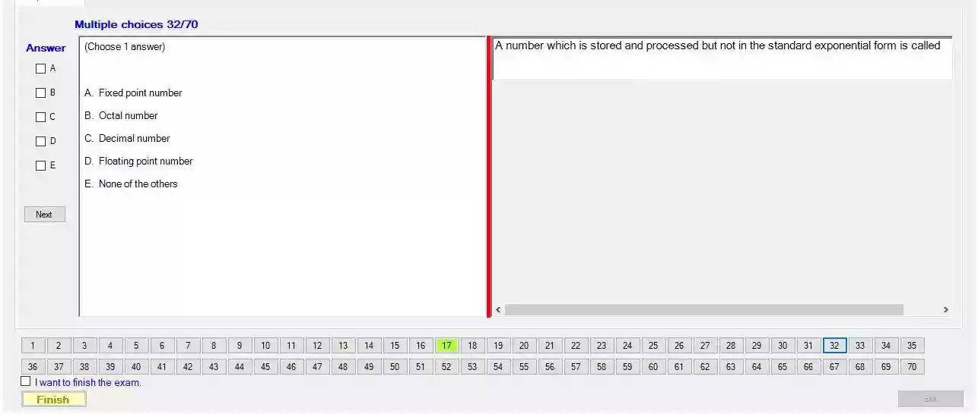

A number which is stored and processed but not in the standard exponential form is called

A. Fixed point number

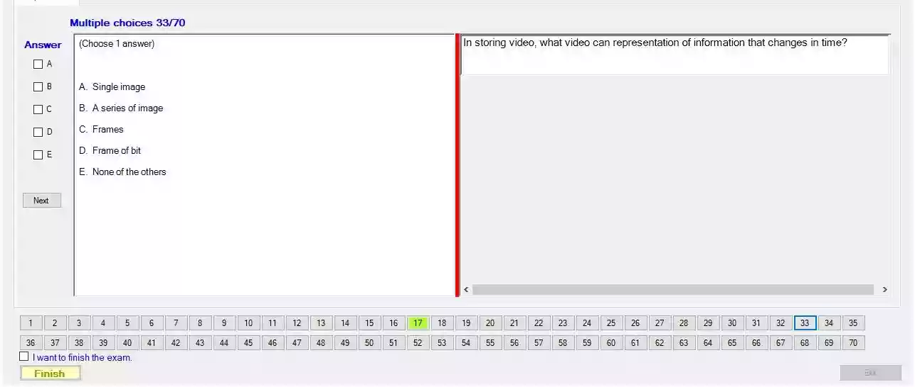

In storing video, what video can representation of information that changes in time?

C/ Frames

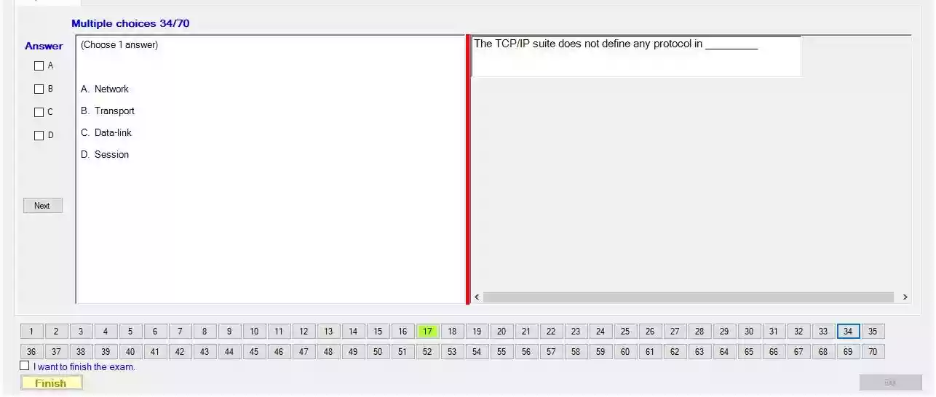

The TCP/IP suite does not define any protocol in

D. Session

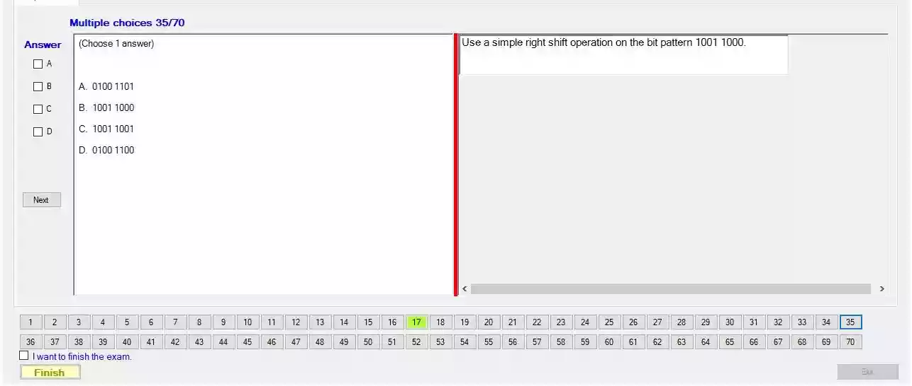

Use a simple right shift operation on the bit pattern 1001 1000.

A/ 0100 1100

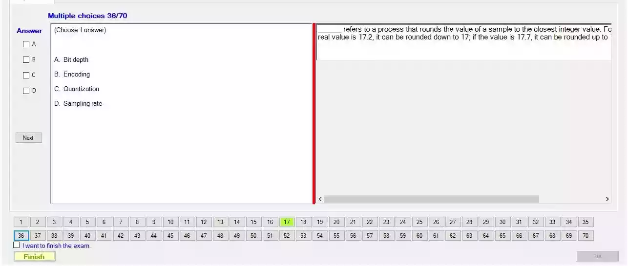

___ refers to a process that rounds the value of a sample to the closest integer value. Fo real value is 17.2, it can be rounded down to 17; if the value is 17.7, it can be rounded up to

C/ Quantization

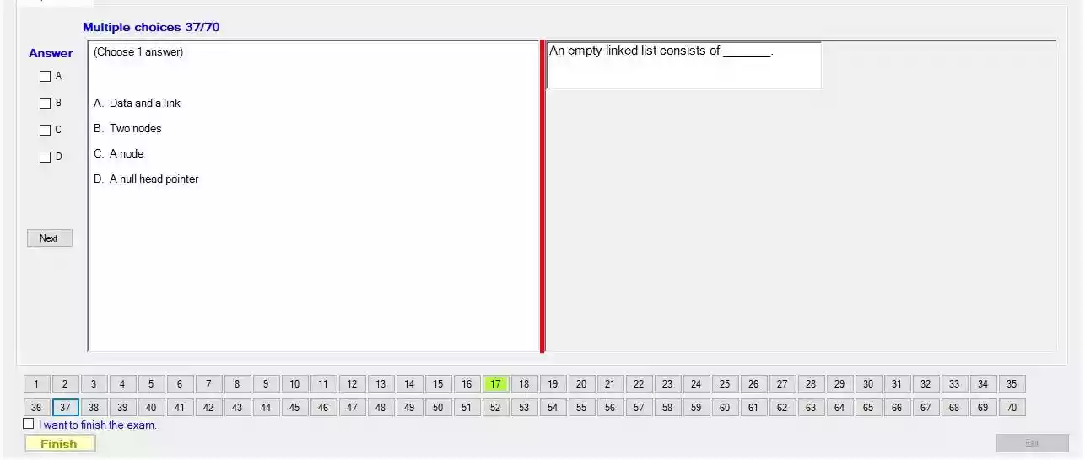

An empty linked list consists of ___

D/ A null head pointer

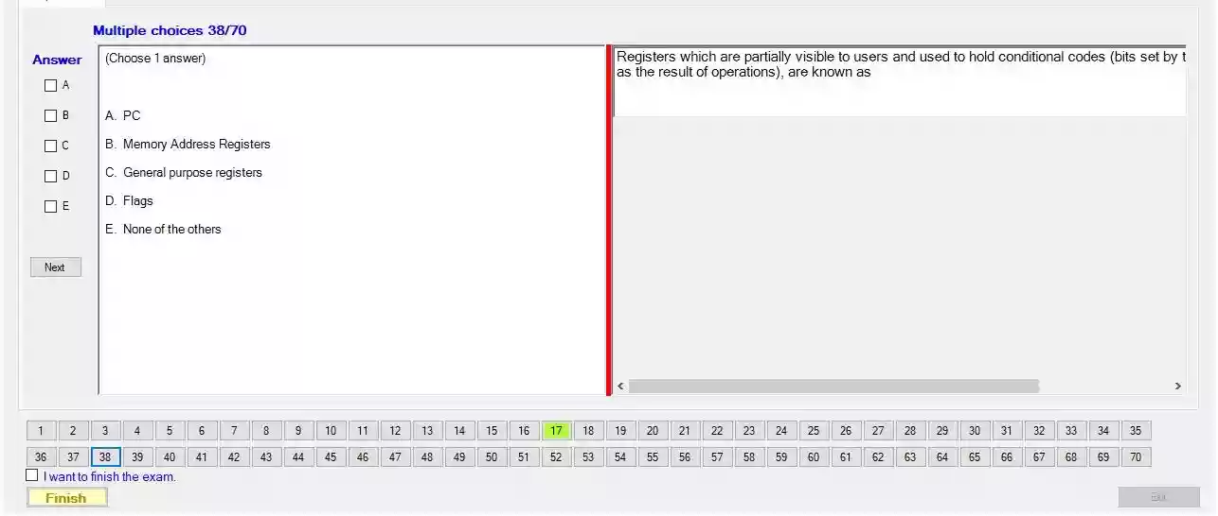

Registers which are partially visible to users and used to hold conditional codes (bits set by as the result of operations), are known as

D. Flags.

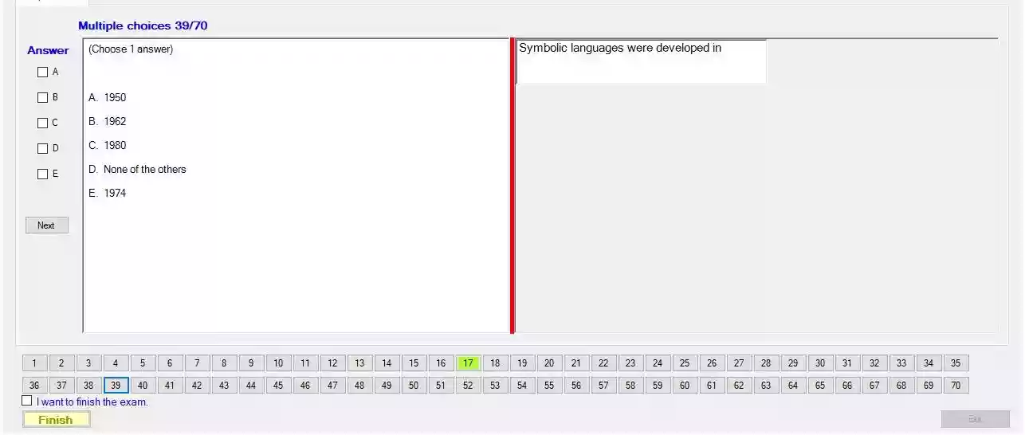

Symbolic languages were developed in

A/ 1950.

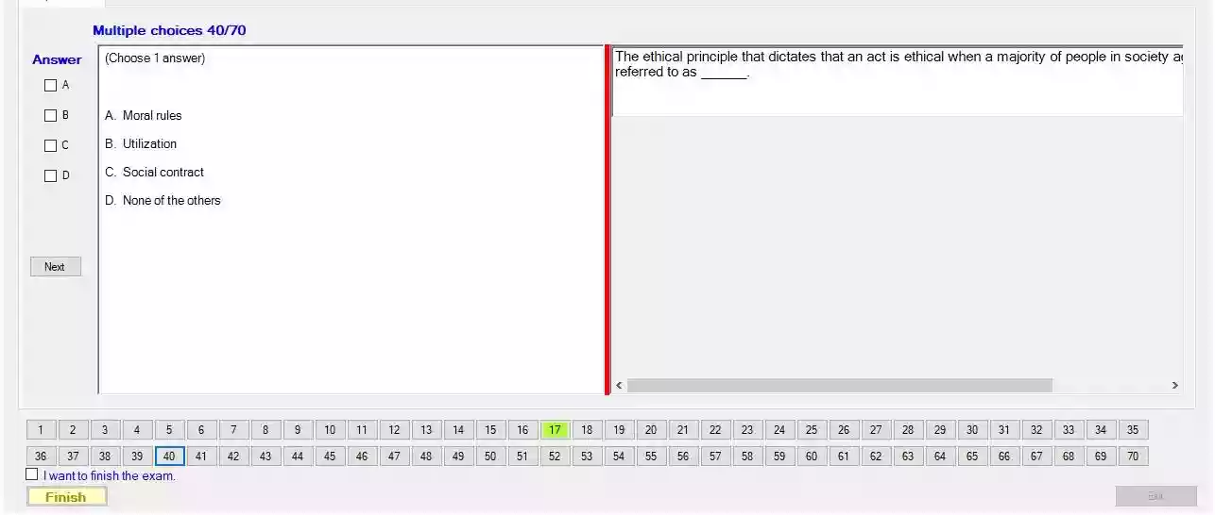

The ethical principle that dictates that an act is ethical when a majority of people in society a referred to as ___

C. Social contract.

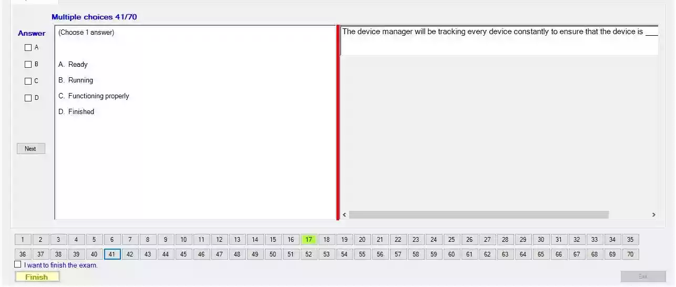

The device manager will be tracking every device constantly to ensure that the device is __

C. Functioning properly.

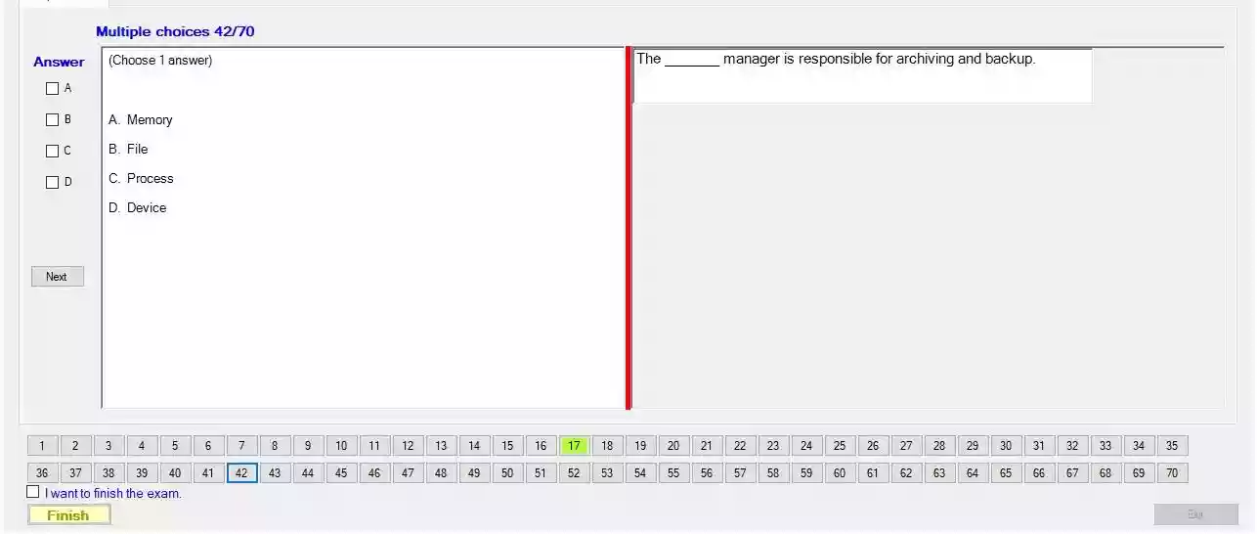

The __ manager is responsible for archiving and backup.

B/ File.

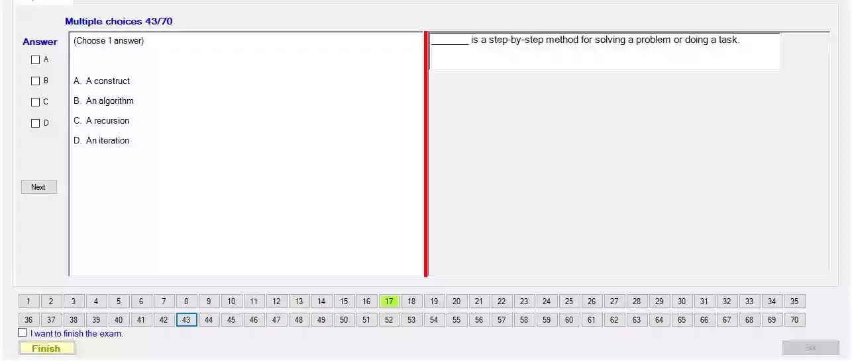

__ is a step-by-step method for solving a problem or doing a task.

B. An algorithm.

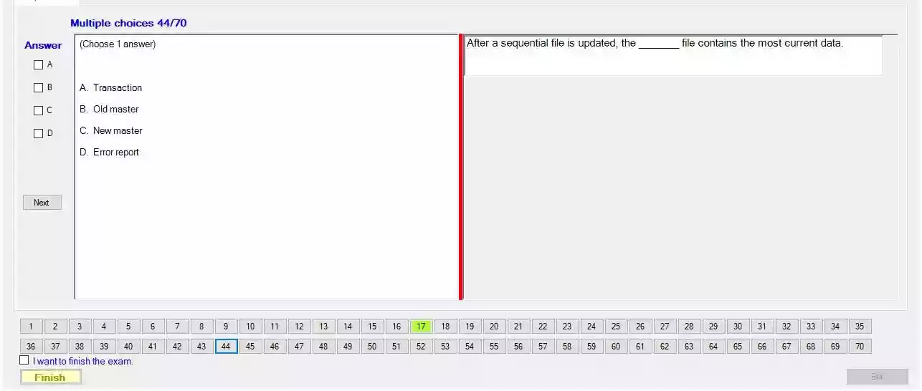

After a sequential file is updated, the __ file contains the most current data.

C. New master.

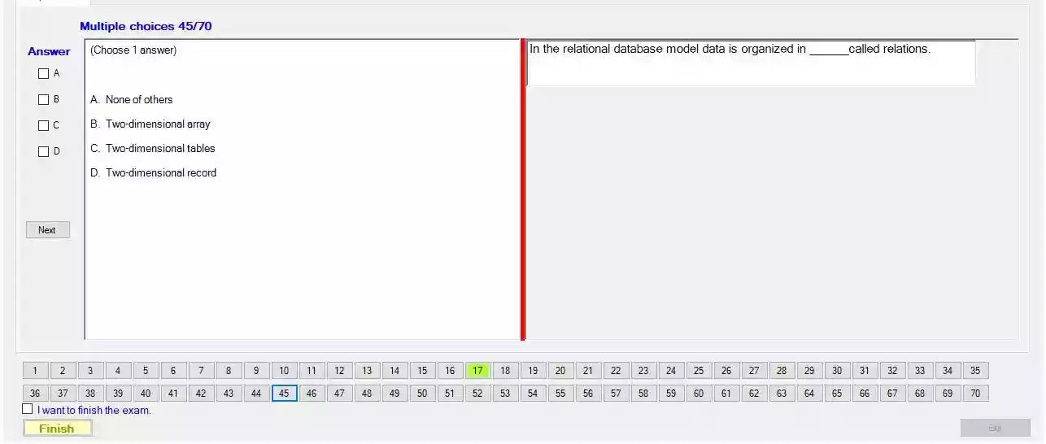

In the relational database model data is organized in ___ called relations.

C. Two-dimensional tables.

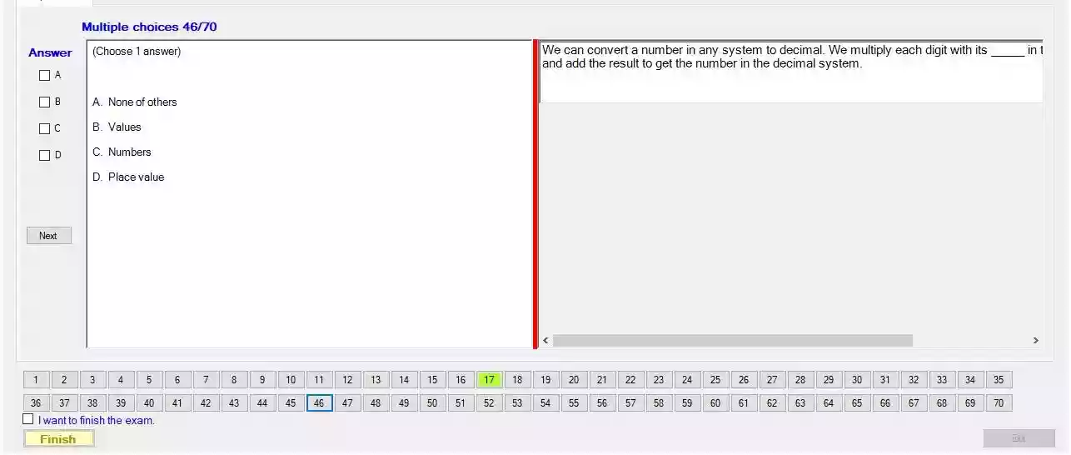

We can convert a number in any system to decimal. We multiply each digit with its ___ and add the result to get the number in the decimal system.

D. Place value.

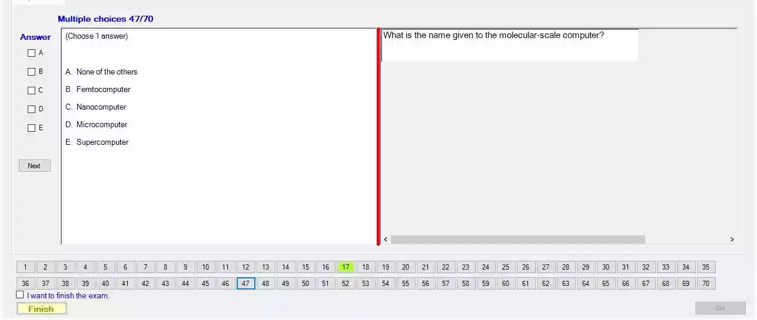

What is the name given to the molecular-scale computer?

C. Nanocomputer.

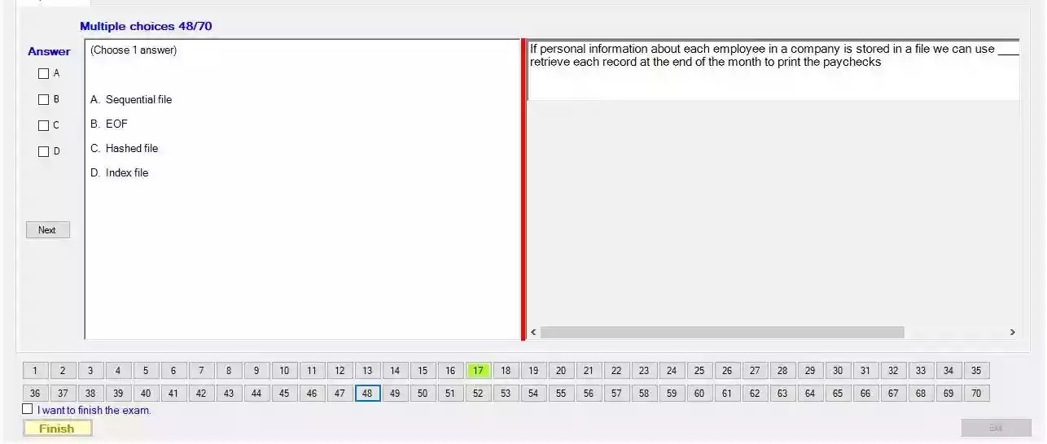

If personal information about each employee in a company is stored in a file we can use ___ retrieve each record at the end of the month to print the paychecks

A. Sequential file.

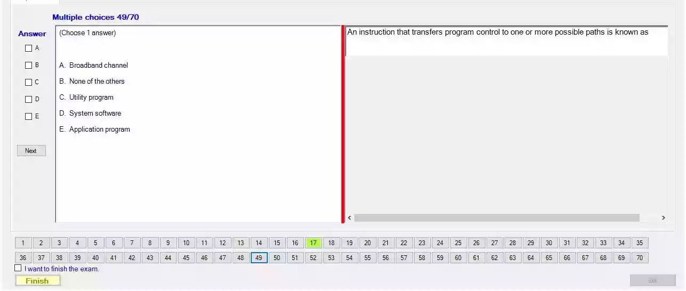

An instruction that transfers program control to one or more possible paths is known as

A/ Broadband channel

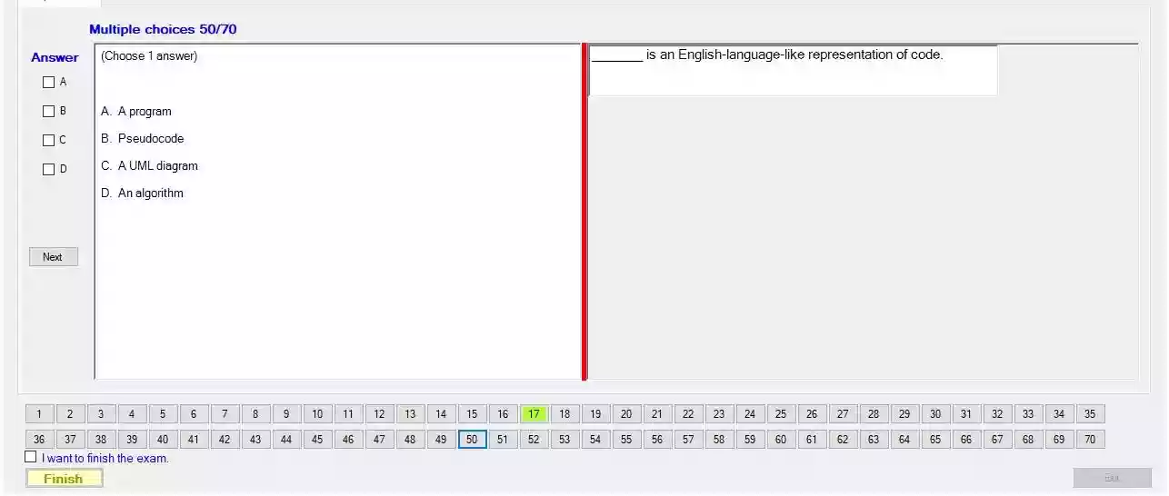

___ is an English-language-like representation of code.

B. Pseudocode.

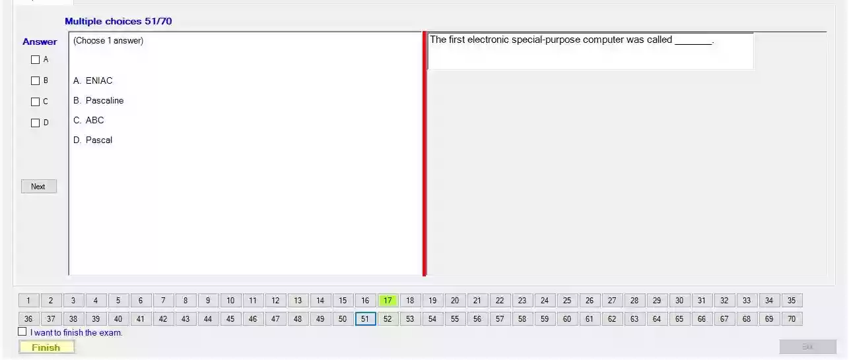

The first electronic special-purpose computer was called

A. ENIAC.

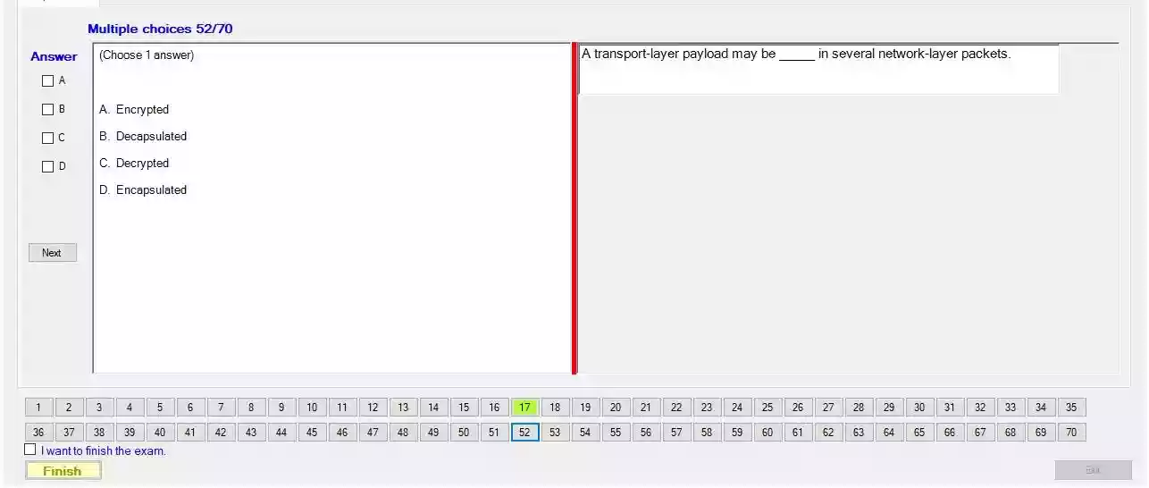

A transport-layer payload may be __ in several network-layer packets.

D. Encapsulated.

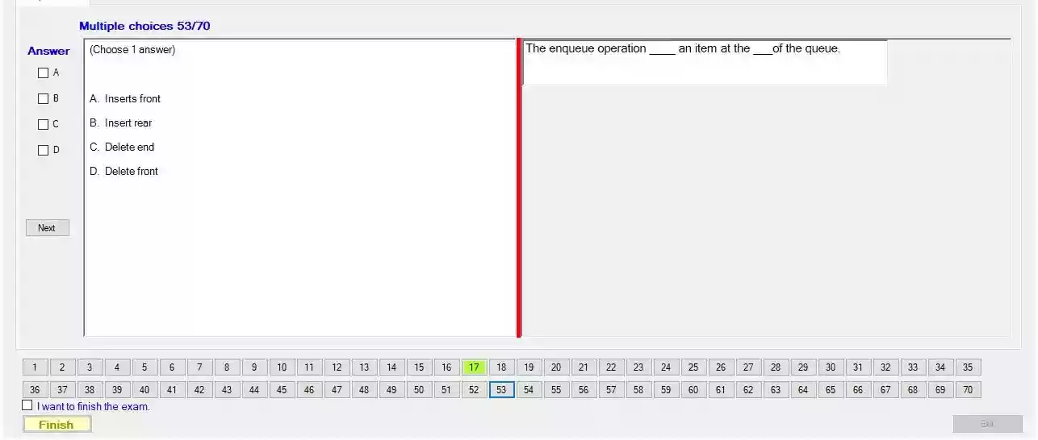

The enqueue operation ___ an item at the ___ of the queue.

B. Inserts rear.

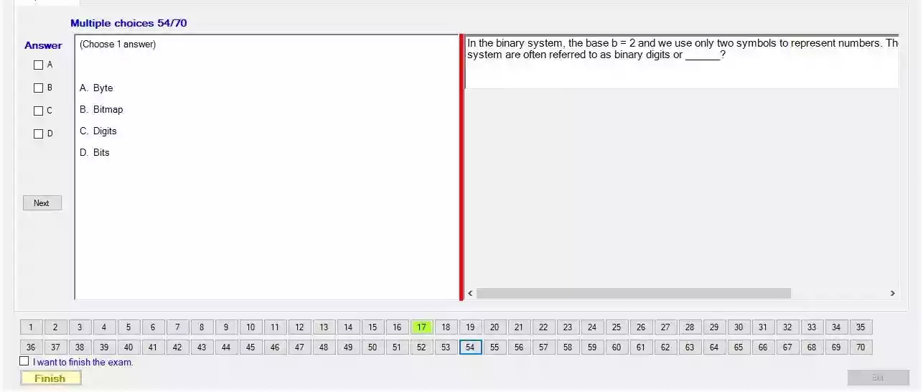

In the binary system, the base b = 2 and we use only two symbols to represent numbers. Th system are often referred to as binary digits or ___ ?

D. Bits.

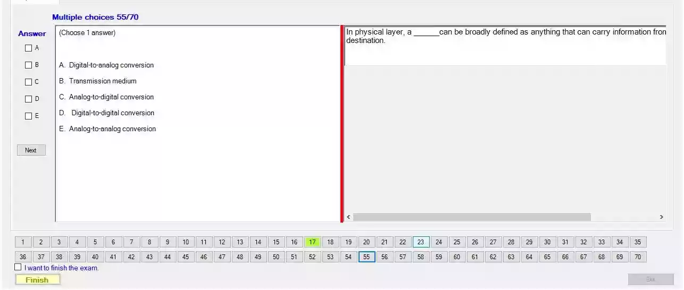

In physical layer, a ___ can be broadly defined as anything that can carry information frondestination.

B. Transmission medium.